PISO_BLOCK
This Block takes the convoluted output from the ALU block in parallel form all bits at once and stores it into an internal register. After the output is stored in the internal register of the PISO block. The data is shifted left one bit at a time (serially starting with the MSB). The most challenging part of this block is managing the bits to make sure dataout[0] does not have some of its bits mixed with dataout[1].
WaveView of the testbench
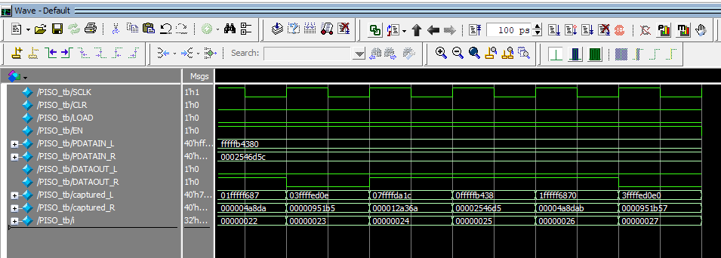

Block Diagram of the PISO block
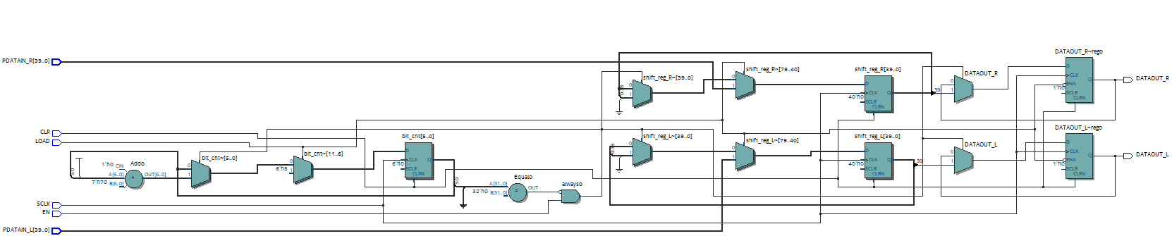

SIPO_BLOCK
The SIPO block takes input data serially one bit at a time and uses the frame to determine when 16 bits are received. It has an internal register to store the incoming bits before they are output to the various memory blocks. A whole row of data is received before the data is passed to PDATA_IN R/L, this means that the internal register is 32 bits long and the first half from Right is for PDATA_IN_R and the second half is for PDATA_IN_L
SIPO Block Diagram
